Final Project-3

XYZ Ads Airing Report Analysis

PLEASE DOWNLOAD THE EXCEL FILE IN THE FOLDER WITH THE NAME “Final Project-3

XYZ Ads Airing Report Analysis” for all the details.

# Project Description:

In order to grow a business's sales or enhance audience awareness of the goods or services, marketing and advertising play the most important roles in order to sell the company. As part of Final Project-3, the analyzed report of some companies’ ads for the year 2021 has been given. In the industry, it is believed that the first impression of any company can be shaped through the ads they air. The advertising industry is particularly cutthroat because many players would spend a lot of money to target the same market. Thus, they market in various methods. Advertisements can easily be stated as a step to convert the audience into consumers. In this project we are going to process the past data collected over airing different ads by different companies and derive meaningful insights and information in the process.

# Approach:

For this project as there happens to be only one dataset it is best to go with a sequential approach where we solve all the given problems one after the other which will help me have better coherence and cohesion with the topic and the task.

# Tech Stack:

Software used: Microsoft Excel, Google Colaboratory

Version: 2103 (16.0.13901.20400)

Developer: Microsoft

Latest Stable Release: April 13, 2021

Purpose: To perform data analysis.

Written in: C++(back-end)

PLEASE DOWNLOAD THE EXCEL FILE IN THE FOLDER WITH THE NAME “Final Project-3

XYZ Ads Airing Report Analysis” for all the details.In the file each task is solved in a different sheet. The sheet name represents which solution it represents. Example sheet “B” is a solution for task “B”

# Task/Solution:

1. **What is Pod Position?**

Sol:

**Ad Pod:** Ad pod is a term used in connection with advertising to specify multiple ads sequenced together and played back-to-back within a single ad break, like traditional linear TV. Ad Pods help multiple commercials to be played in a single break. For instance, while we stream some video on youtube we are suddenly interrupted by an ad break where we can see more than one ad being played which are of entirely different companies.

**Pod Positioning:** The position of an individual advertisement within a certain commercial pod or the position of ad in a sequence of ads. For example, if we have an ad pod which has 3 ads in it: first one from Byju’s, then from Simplilearn and then from Coursera then the Pod position of Simplilearn in that pod is 2.

**Does the Pod position number affect the amount spent on Ads for a specific period of time by a company?**

The pod position and the amount spent have a weak negative correlation between each other of about -0.0057 which signifies that they are not correlated on the whole.

| Overall Correlation | |  |
| --- | --- | --- |
|  | Column 1 | Column 2 |
| Column 1 | 1 |  |
| Column 2 | -0.00572 | 1 |

The company “Hyundai Motors India” in the month of November has a correlation of -0.002 and “Mahindra and Mahindra” has -0.04578 in terms of pod position and amount spent which is significantly small.

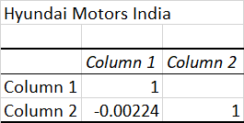

| Mahindra and Mahindra | | |
| --- | --- | --- |
|  | Column 1 | Column 2 |
| Column 1 | 1 |  |
| Column 2 | -0.04578 | 1 |

Since the values are negligibly small therefore we can say that the pod position number does not affect the amount spent on ads.

1. **What is the share of various brands in TV airings and how has it changed from Q1 to Q4 in 2021?**

**Sol:**

Shares of a particular brand in the ad airing can be defined by how much they invested in the ads for a particular period of time.

Ratio-Analysis to determine the change:

| **Company** | **Q1** | **Q4** | **Change** |
| --- | --- | --- | --- |
| Honda Cars | 17641924 | 9097227 | -48% |
| Hyundai Motors India | 63300421 | 37136580 | -41% |
| Mahindra and Mahindra | 128387916 | 73201159 | -43% |
| Maruti Suzuki | 187686495 | 116809533 | -38% |
| Tata Motors | 27525724 | 36064839 | 31% |
| Toyota | 40137985 | 13999979 | -65% |

The values specify the change from Q1 to Q4 in percentages. We can see that only “Tata Motors” has increased its shares and all others have significantly reduced.

1. **Conduct a competitive analysis for the brands and define advertisement strategy of different brands and how it differs across the brands.**

**Sol:**

In this competitive analysis I have considered two most important aspects: Sector of the day companies are targeting and how much did they invest in that sector over the year.

From the analysis one can conclude the following:

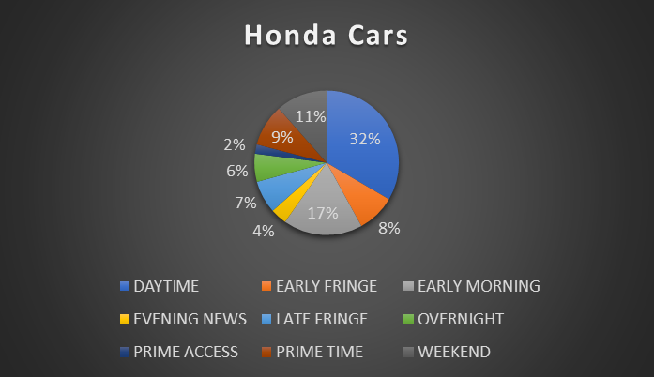

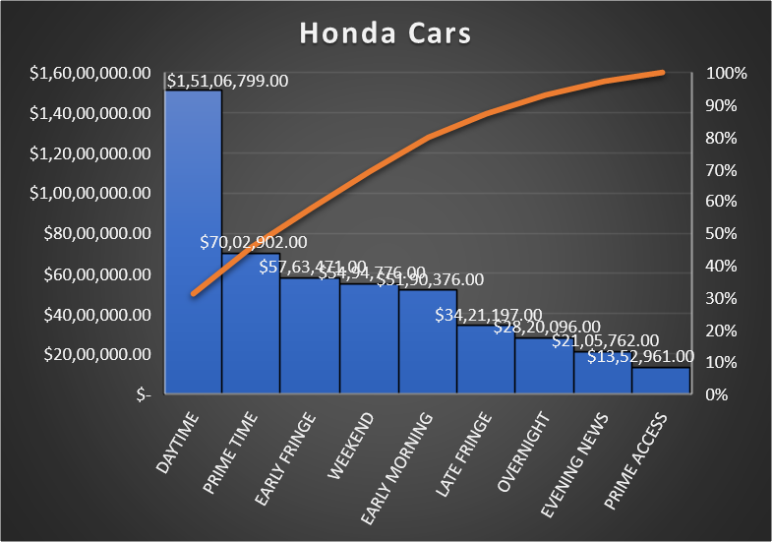

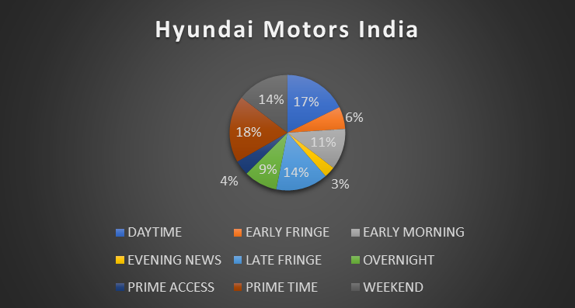

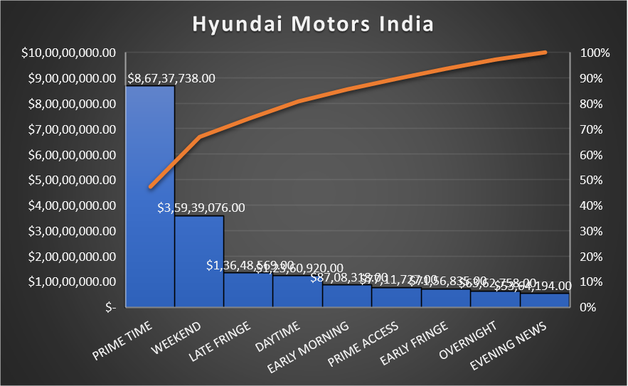

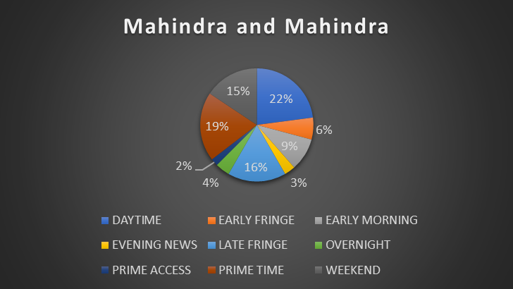

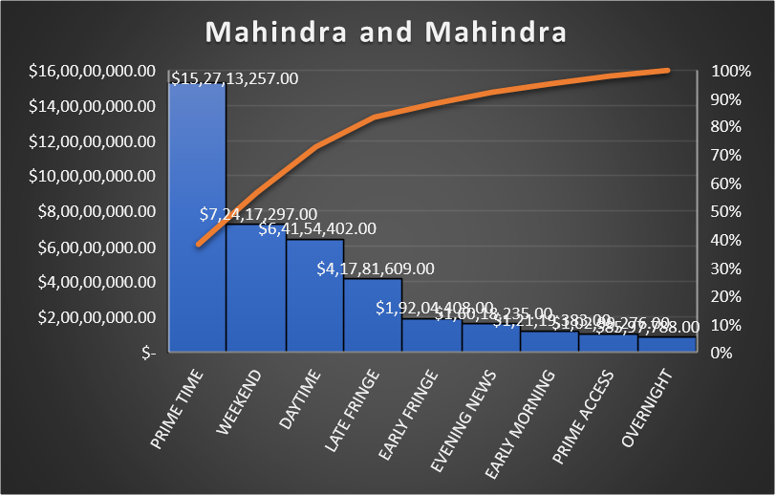

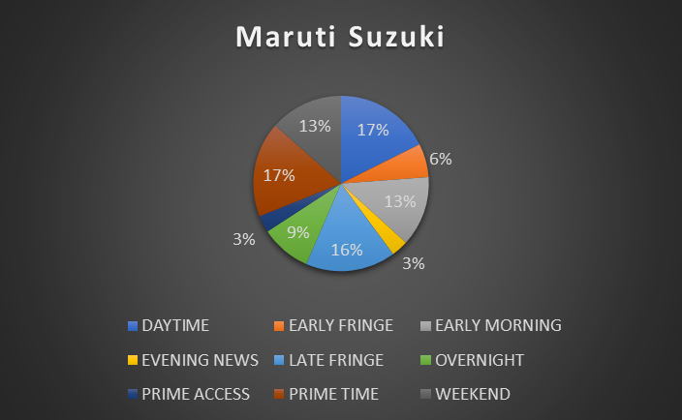

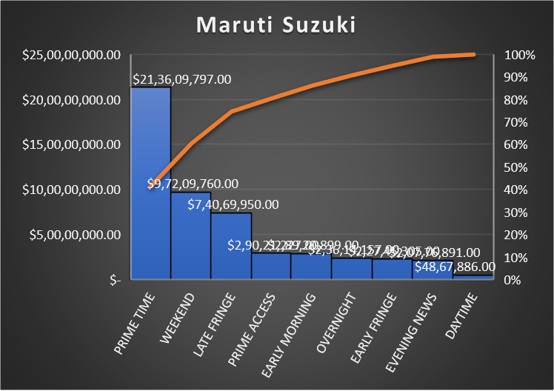

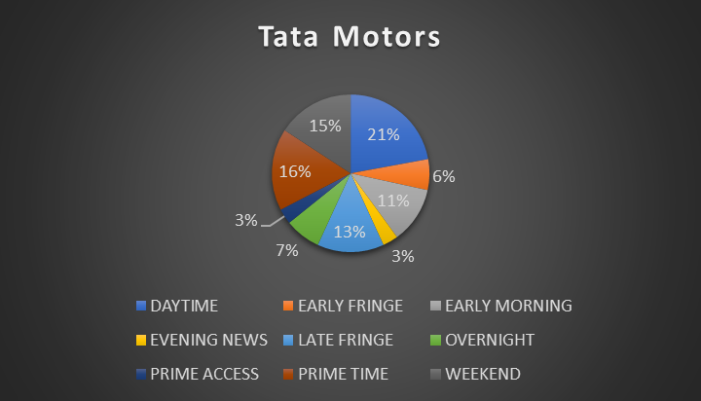

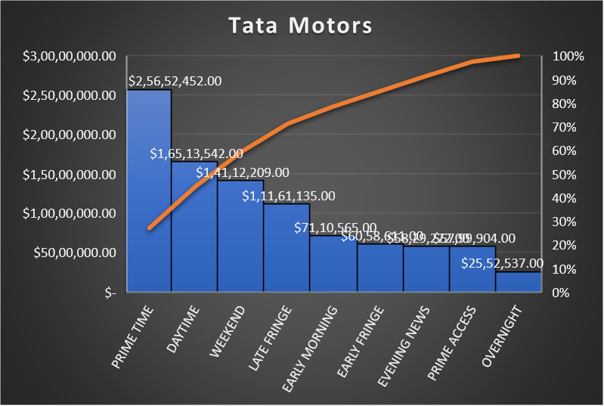

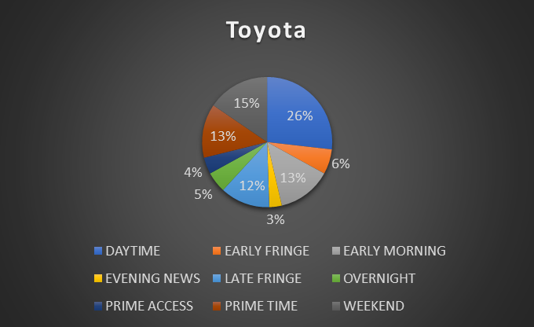

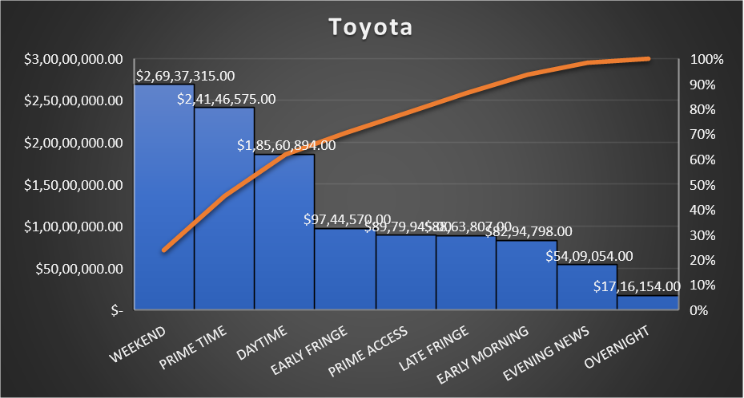

* Most of the companies are targeting the “DAYTIME” sector more than any other.
* On the top is “Honda Cars” with 32% of its annual ads falling under “DAYTIME”. Also the highest the company invested in ads in this sector (about 1Cr).
* One should also see that “Maruti Suzuki” invested the least in “DAYTIME” which simply shows the brains of the company because when all the companies compete for this sector it simply invests in other premium sectors. Moreover it stands at the top when it comes to the money a company invested in ads with a benchmark of 21,36,09,797.00 Rupees.
* Companies like “Hyundai Motors India”, “Mahindra and Mahindra” and “Tata Motors” had a considerably equivalent trend with similar investments yet varied in numbers. From these three “Mahindra and Mahindra” invested the highest in ads and “Tata Motors” invested the least which is also the least among all.
* “Toyota” stands out by making its highest investment of 2.69Cr in the “WEEKEND” sector airing 15% of its annual ads in this sector.

1. **Mahindra and Mahindra wants to run a digital ad campaign to complement its existing TV ads in Q1 of 2022. Based on the data from 2021, suggest a media plan to the CMO of Mahindra and Mahindra. Which audience should they target? *Assume XYZ Ads has the ad viewership data and TV viewership for the people in India.**

**Sol:**

From the analysis on “Mahindra and Mahindra” one can find out that in the year of 2021 it had invested a huge sum of about 40M in the ads, however it chose to put most of the amount in the “PRIME TIME” sector yet aired most of it’s ads in the “DAYTIME” sector.

| **Sector/Target** | **Percentage of ads aired** | **Amount Invested** |
| --- | --- | --- |
|  |  |  |
| DAYTIME | 22% | $ 6,41,54,402.00 |
| EARLY FRINGE | 6% | $ 1,92,04,408.00 |
| EARLY MORNING | 9% | $ 1,21,19,383.00 |
| EVENING NEWS | 3% | $ 1,60,18,235.00 |
| LATE FRINGE | 16% | $ 4,17,81,609.00 |
| OVERNIGHT | 4% | $ 85,97,788.00 |
| PRIME ACCESS | 2% | $ 1,02,99,276.00 |
| PRIME TIME | 19% | $ 15,27,13,257.00 |
| WEEKEND | 15% | $ 7,24,17,297.00 |

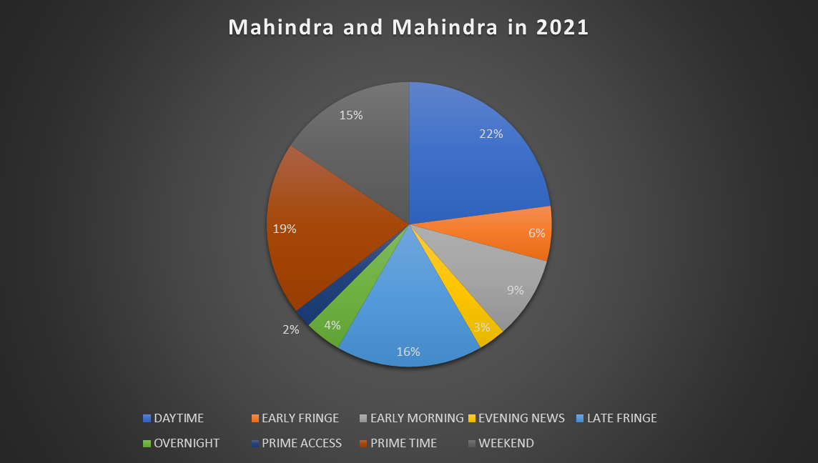

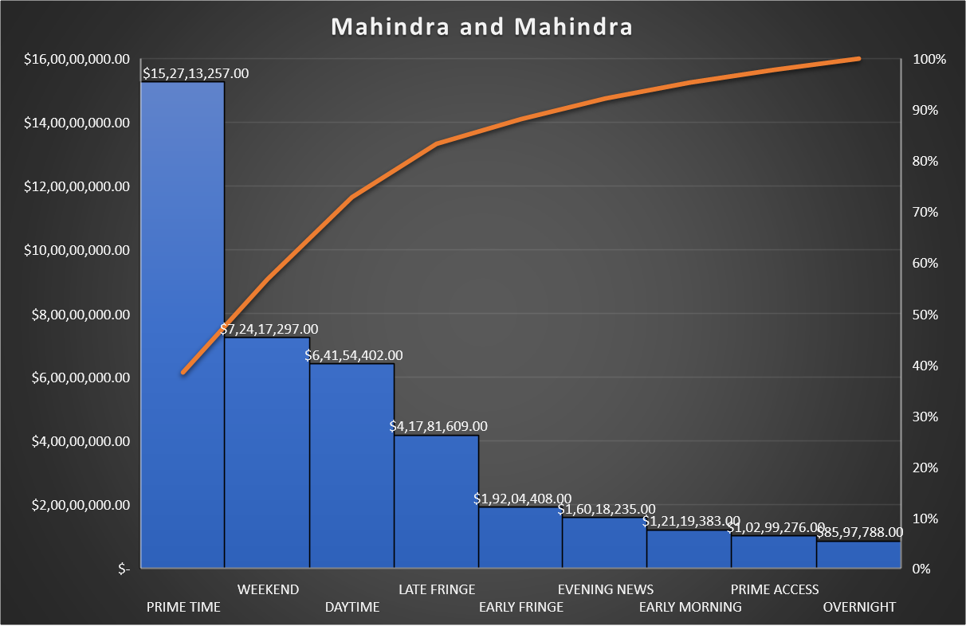

A complete contradiction would be to target “OVERNIGHT” or “PRIME ACCESS” audience as it has aired the least ads in time of the day in the last year.

Another way to decide for the question would be product-value analysis. In the last tenure it has invested 96% of its annual ads to advertise “Mahindra New Thar” hence to complement that the company can publicize other products like “Mahindra Scorpio” or “Mahindra XUV 700” most and “Mahindra New Thar” least.

| **Product** | **Percentage of ads aired** | **Amount Invested** |
| --- | --- | --- |
| **Mahindra New Thar** | **96%** | **393217909** |
| **Mahindra Scorpio** | **1%** | **2278229** |
| **Mahindra XUV 700** | **2%** | **1809517** |

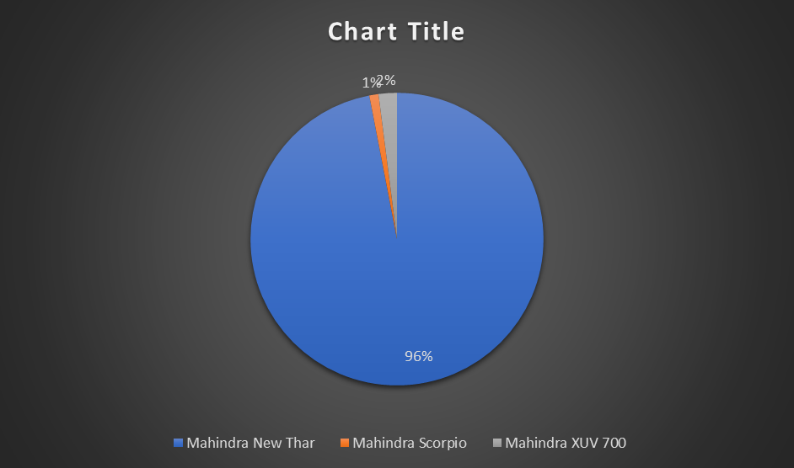

# Insights:

Insights refers to accurate understanding of something. These points helps in an insightful understanding of the problems:

* All the problems refer to real-life situations which any data analyst would face while dealing with data. The attributes may differ but the application or approach will not change.
* Here we are dealing with a dataset that is developed based on Ads aired by six different companies in the year of 2021
* There were about 731785 records on the whole, 19 different attributes, 6 different companies.
* The data helped in many types of analysis possible and draw insights

# Result:

To recapitulate, the results are elaborately discussed above, moreover this project/task helped me in better understanding of Excel and its limitations. It also enhanced my Critical Thinking and Problem-Solving skills. (I could not solve all the questions by using joins. However I managed to draw conclusions using other concepts which are hopefully right).

Thank You.